

Registration Form

Yes, I will attend ZIMT 09

□ on Friday, 10th of July 2009

and/or

□ on Saturday, 11th of July 2009

Name: _______________________________________

Please fill in this form and send it back to us by
fax (+43 732/73 83 94-4) or
e-mail (zimt@linz.aikammeros.org) by June 26th 2009.

Contact information:
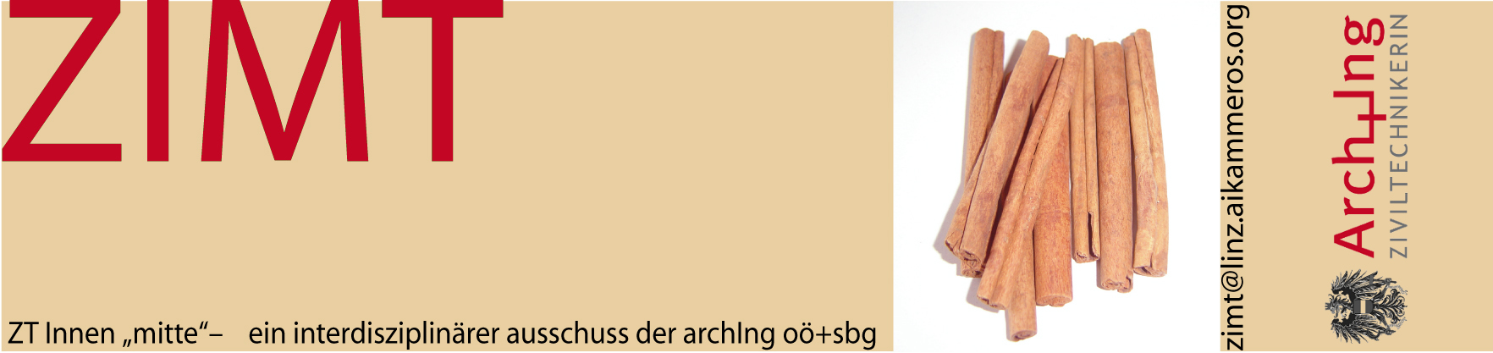

Ziviltechnikerinnen Mitte – an interdisciplinary committee
within the Chamber of Architects and Chartered Engineering
Consultants, Federal Section of Upper Austria and Salzburg
Kaarstraße 2/II, A-4040 Linz
Phone: +43 732/73 83 94-0, Fax: +43 732/73 83 94-4
Mail: zimt@linz.aikammeros.org
www.aikammeros.org

