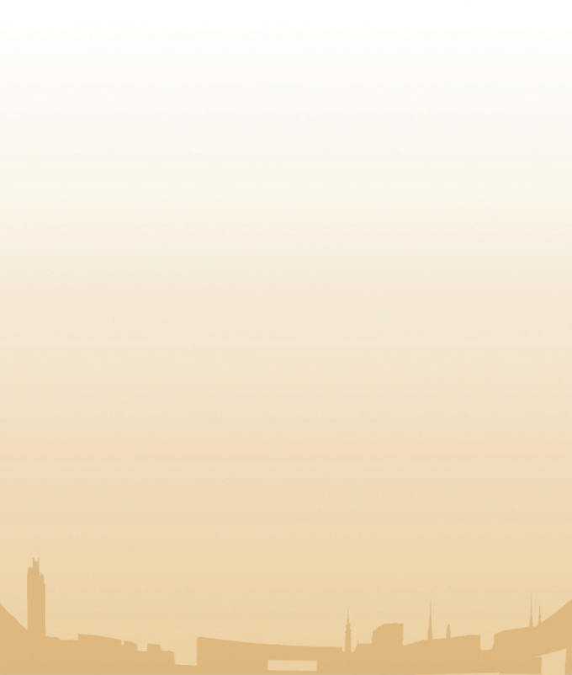
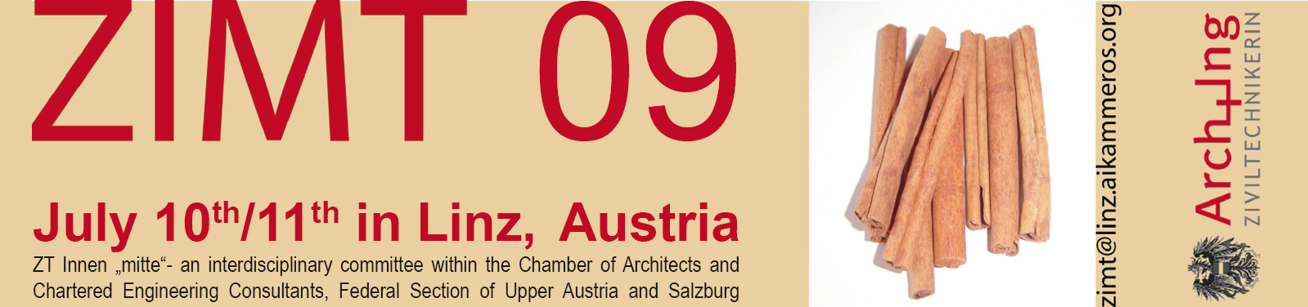

Application form – Short talk

Author

Surname, Forename:
Company:
Address:
Country: | Photo
Date of birth:
E-Mail:
Phone:
Fax:

Short talk

Title
Summary
(max. 100 words)

Formal guidelines for submission:

- Max. one page, DIN A4
- PDF-format
- Please send your application attached to this form to zimt@linz.aikammeros.org (by May 1st).

